Exciting research experiment with Pranic Distant Healing
Dr Masaru Emoto, is an internationally renowned researcher on water and his laboratory , in Japan, examines frozen water crystals under a microscope and photographs them with special equipment.
On 24th July 2003 Dr Hazel Wardha coordinated a research experiment with Dr Masaru Emoto laboratory. 12 Pranic healers from Melbourne and Master Gregory Castanarez from Manila projected Pranic energy to a Tokyo tap water sample placed in Dr Emoto laboratory in Japan.
The treated water sample and the control water sample were frozen and their crystals were examined under a microscope and photographed with a special camera. The beautiful crystal formation in the water sample , treated with Pranic healing, has yielded an exciting result, which validates the power of Pranic healing , to alter states of matter, even from a distance.
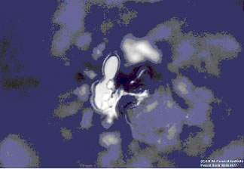
Picture 1 : Control water sample of Tokyo tap water. This sample did not receive Pranic energy
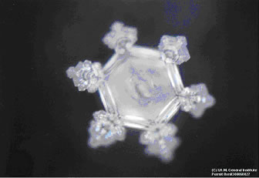
Picture 2. Water sample of Tokyo tap water after being treated with Pranic healing.

